Nome:_________________________________________ Data:___/___/______
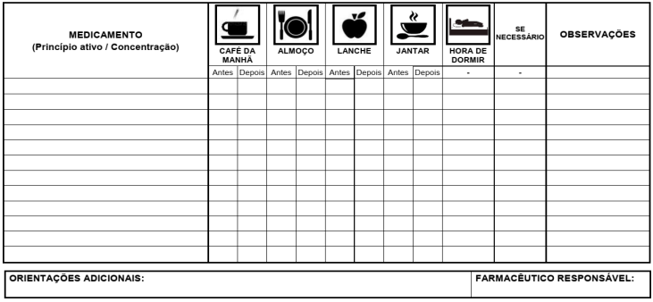

Nome:_________________________________________ Data:___/___/______


